de Gucena 2018-01875

Feature Activity 06 Documentation

Listing networks

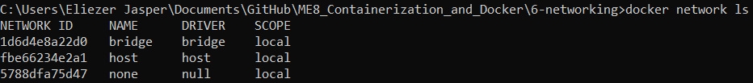

The default “bridge” network

Managing custom networks

Adding containers to a network

Connecting between containers in a network

Binding ports to the host

